

COS80001 – Cloud Engineering  
Assignment 2: Deploying a Photo Album Web Application on Oracle Cloud Infrastructure (OCI)

Student Name: Arun Ragavendhar Arunachalam Palaniyappan  
Student ID: 104837257  
Tutorial Time: Friday – 04:30 PM to 06:30 PM  
Tenancy Name: s104837257

Contents

I. INTRODUCTION 3

II. INFRASTRUCTURE SETUP 3

A. VCN and Subnet Configuration 3

B. Network Security Groups (NSGs) 6

C. Virtual Machine Instances 6

D. MySQL Database Setup 7

E. Security Lists 8

III. PHOTO ALBUM APPLICATION DEPLOYMENT 9

A. OCI Object Storage Bucket 9

B. Metadata Entry and Storage in MySQL DB 11

C. Web Application Setup 11

IV. TESTING AND VALIDATION 12

A. Ping Connectivity Between Web Server and Test Instance 12

B. Photo Album Website Access Test 12

C. phpMyAdmin Database Test 13

D. Object Storage Access Test 13

E. Website Restart and Reserved IP Persistence 13

V. CHALLENGES AND LEARNINGS 13

VI. CONCLUSION 13

VII. REFERENCES 13

VIII. APPENDIX 14

A. Abbreviations 14

B. List of Figures 14

# **I. INTRODUCTION**

This report explains how a photo album website was successfully deployed using Oracle Cloud Infrastructure (OCI). This included setting up the entire cloud environment, securing the network, deploying a MySQL database, storing images in Object Storage, and running a PHP web app on a virtual machine. Tools used include VCN, subnets, routing, NSGs (Network Security Groups), Security Lists, Reserved Public IP, and phpMyAdmin.

Public URL of the Website: **http://132.226.49.124/cos80001/photoalbum/album.php**

IAM user has been created for tutor and private key - **arunKeyPair**

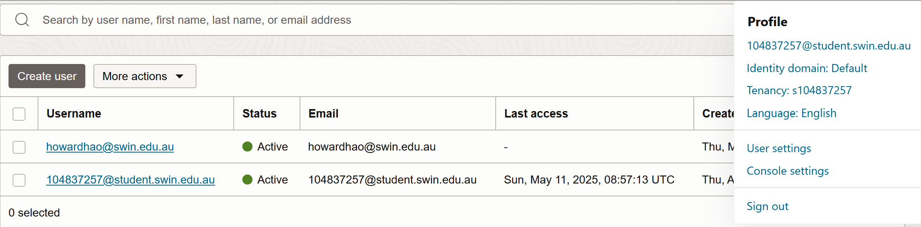

*Figure 1: IAM user created for Tutor*

# **II. INFRASTRUCTURE SETUP**

The full infrastructure was built from scratch in OCI using a custom Virtual Cloud Network (VCN). The setup involved four subnets, two in each availability domain — public and private.

**A. VCN and Subnet Configuration**

As part of the security configuration, two Network Security Groups (NSGs) were created and applied to relevant components within the VCN. The first group, named Web-tierNSG, was responsible for managing access to the web server. It allowed HTTP (port 80) and SSH (port 22) traffic from any source, permitted ICMP packets from the test subnet (Private Subnet 2), and accepted MySQL connections coming from the database subnet (Private Subnet 1). The second group, Test-InstanceNSG, was more permissive, enabling all inbound traffic to the test instance and allowing ICMP responses to reach the public subnet, primarily for testing internal connectivity.

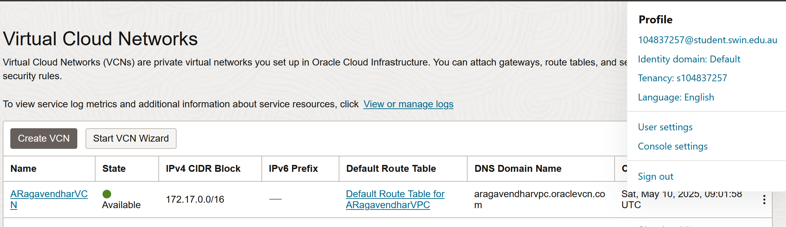

*Figure 2: VCN Created in OCI Using CIDR Block 172.17.0.0/16*

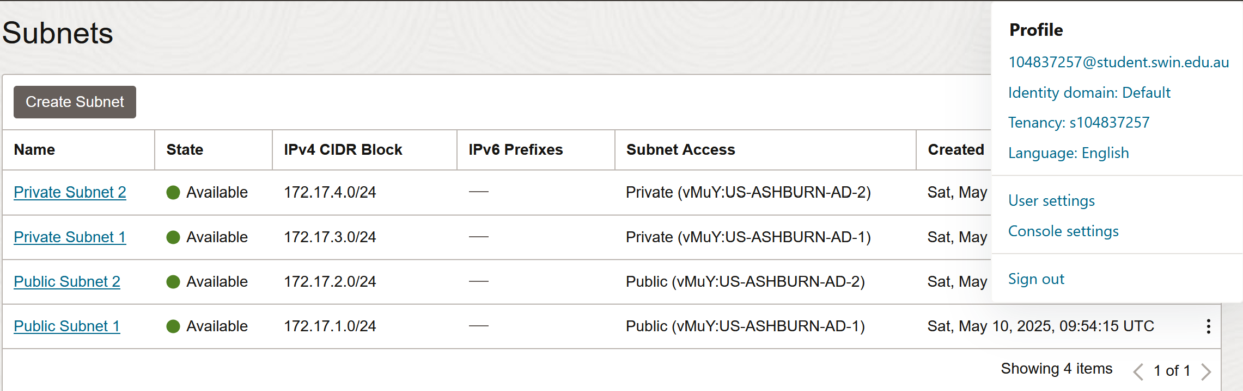

*Figure 3: The 4 subnets and their CIDRs and Availability Domains*

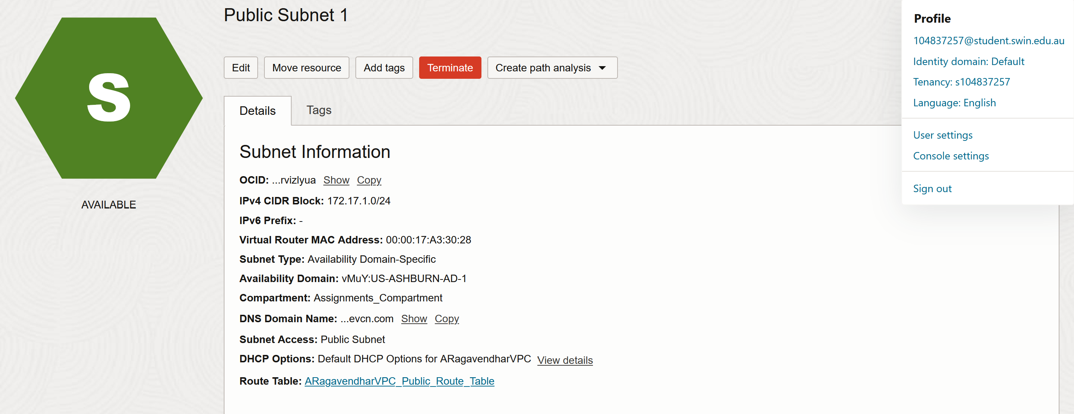

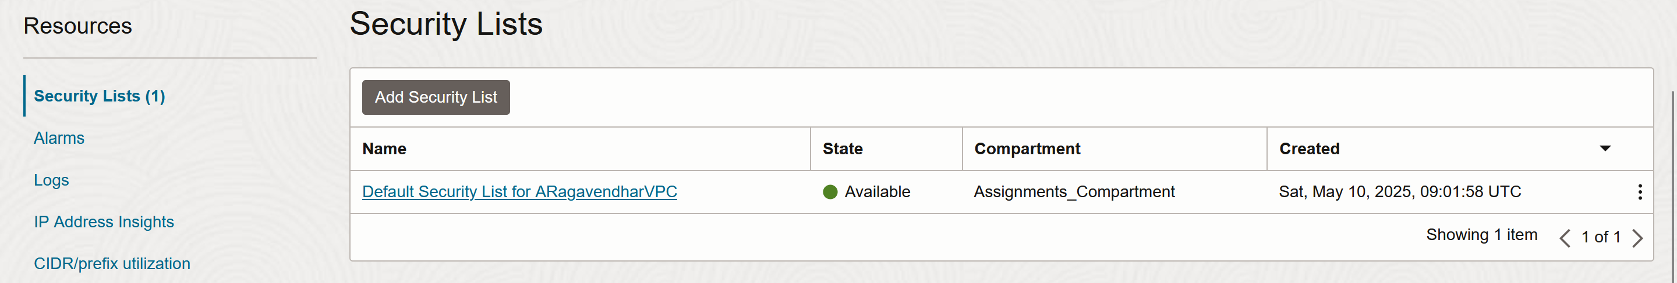

*Figure 4: Public Subnet 1 configurations – associated route table and associated security list*

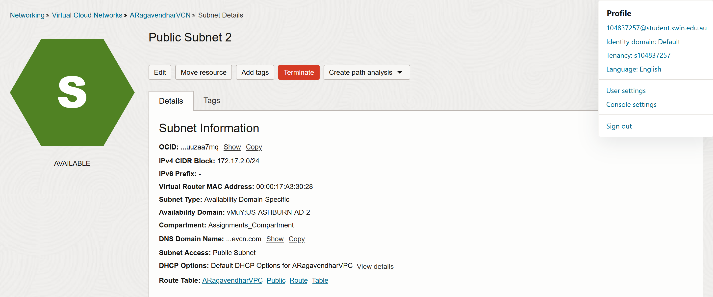

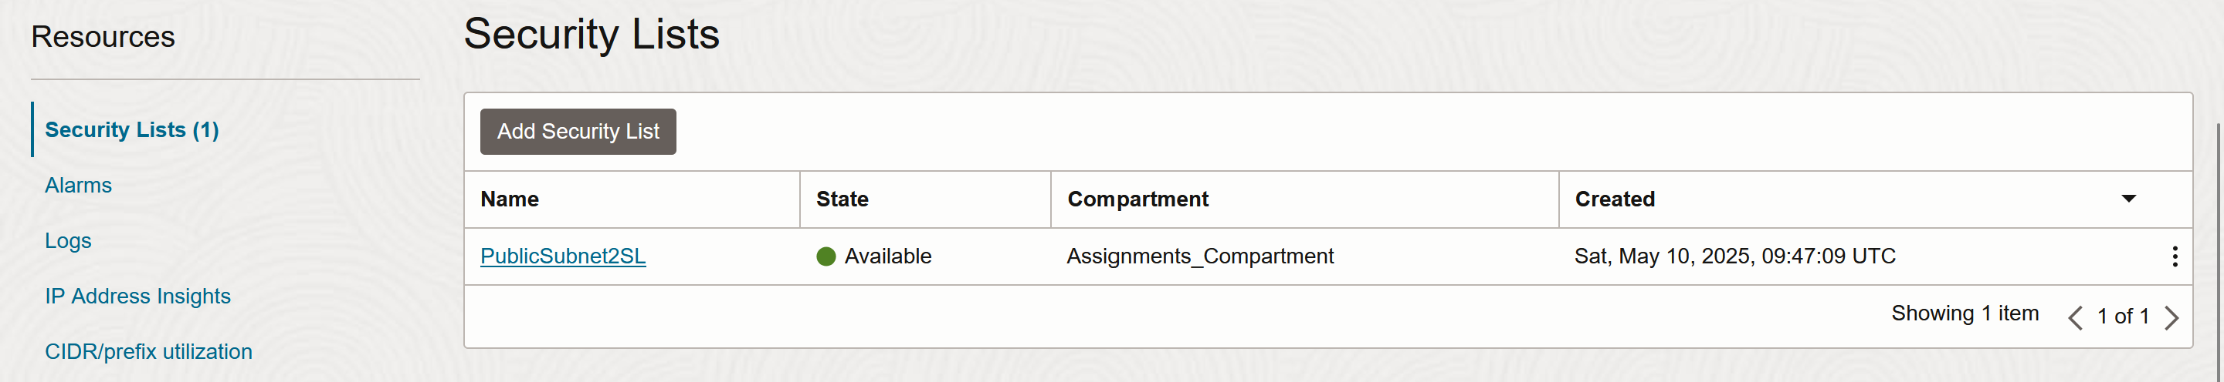

*Figure 5: Public Subnet 2 configurations – associated route table and associated security list*

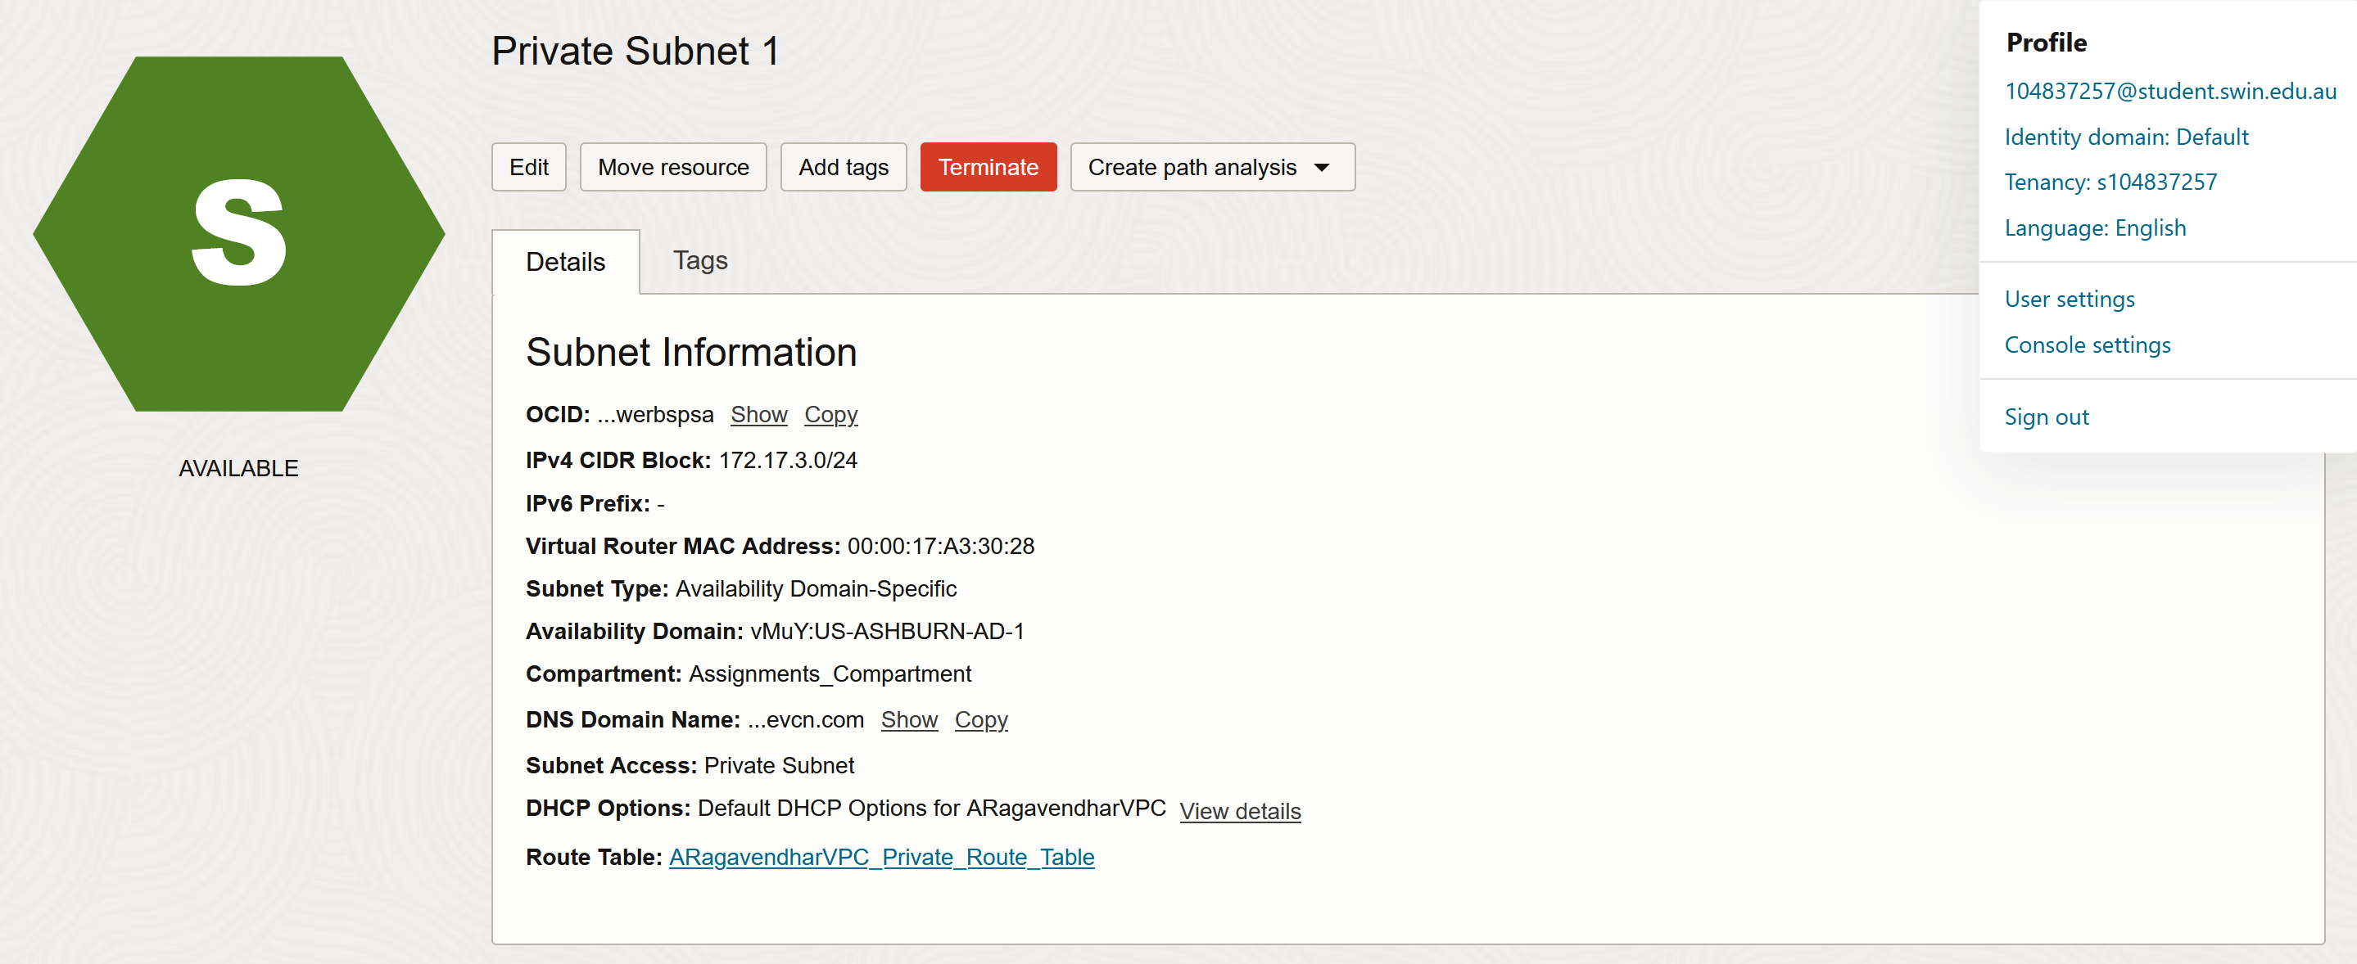

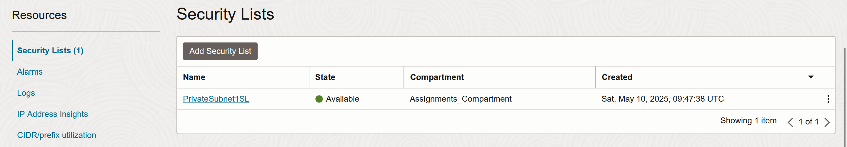

*Figure 6: Private Subnet 1 configurations – associated route table and associated security list*

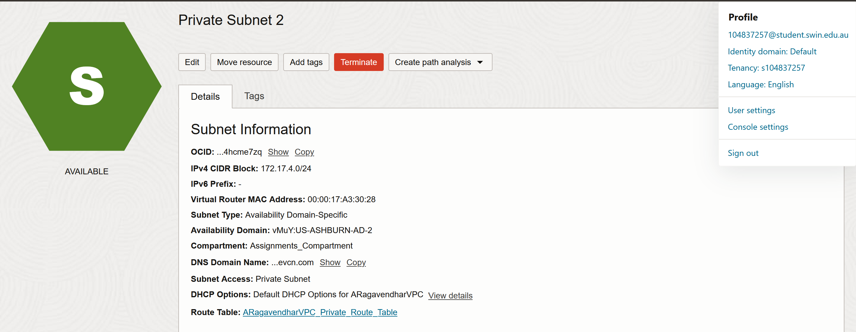

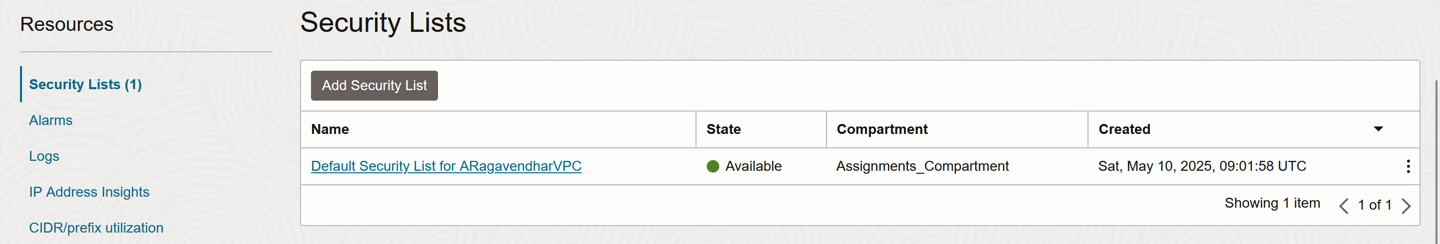

*Figure 7: Private Subnet 2 configurations – associated route table and associated security list*

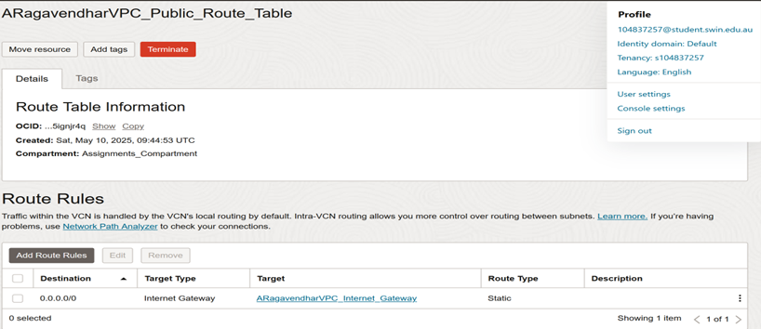

*Figure 8: The public route table attached to the internet gateway*

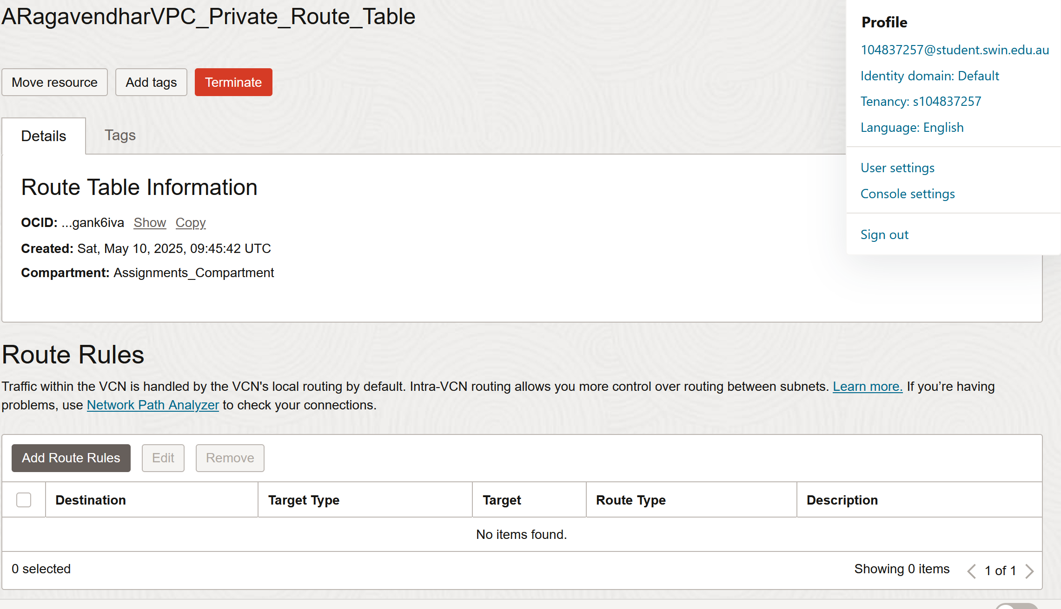

*Figure 9: The private route table with no internet access*

**B. Network Security Groups (NSGs)**

As part of the network configuration, two Network Security Groups (NSGs) were created to manage traffic at the instance level. The first group, called Web-tierNSG, was attached to the web server and configured to accept HTTP (port 80) and SSH (port 22) connections from any external source. It also allowed ICMP traffic originating from the subnet where the test instance was placed (Private Subnet 2), and accepted MySQL-related traffic from the database subnet (Private Subnet 1). The second group, named Test-InstanceNSG, was assigned to the test virtual machine and configured to allow all types of inbound connections, with ICMP traffic permitted outbound specifically toward the public subnet where the web server was located [1].

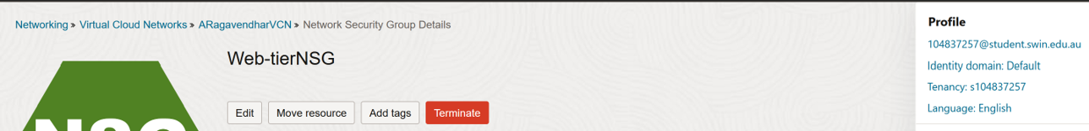

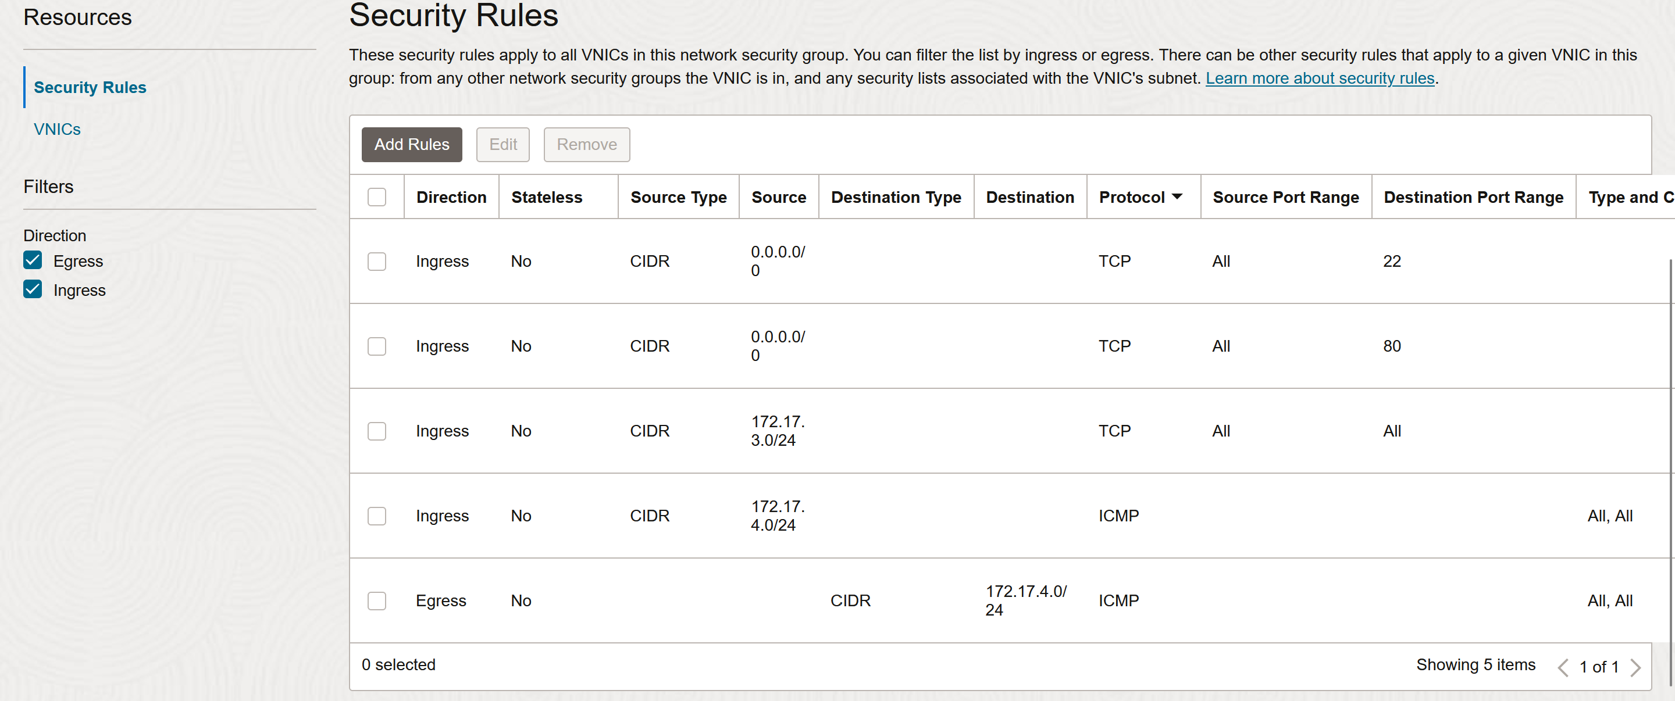

*Figure 10: Web-tierNSG with Ingress (4 rules) and Egress (1 rule) Settings*

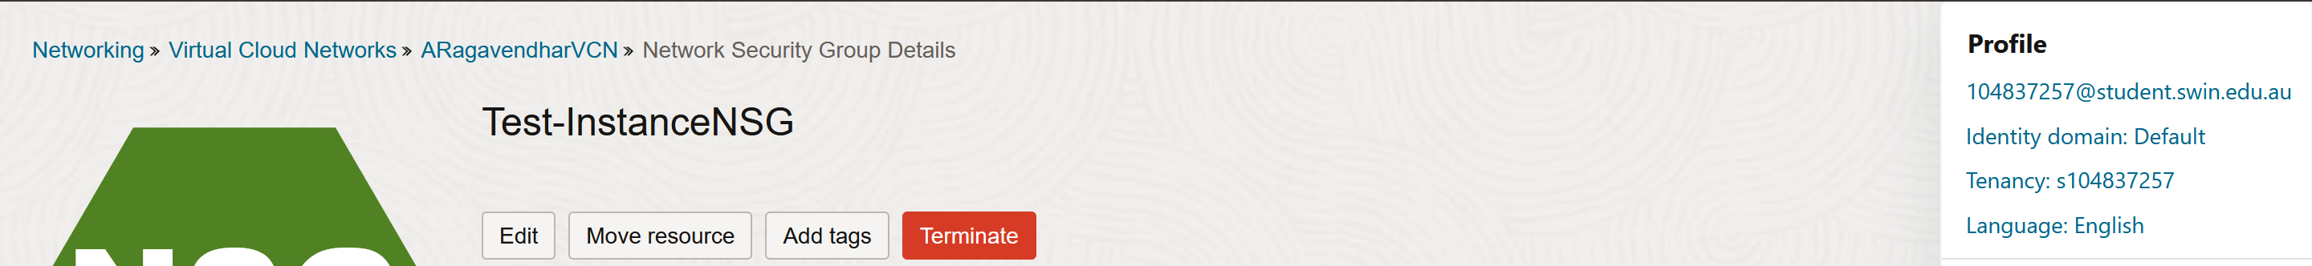

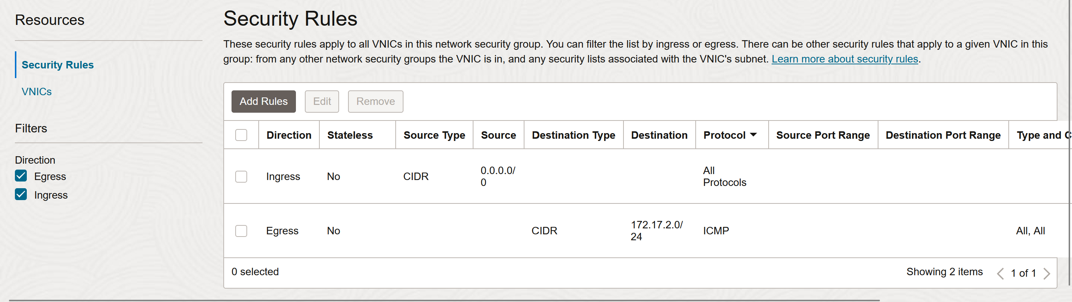

*Figure 11: Test-InstanceNSG with Ingress (1 rule) and Egress (1 rule) Settings*

**C. Virtual Machine Instances**

Two virtual machines were deployed within the VCN. The first was a Web Server/Bastion Host, launched in Public Subnet 2 using Oracle Linux 8 with the VM.Standard.E2.1 shape. It had Apache, PHP, and phpMyAdmin installed via a provided bash script. The second was a Test Instance, created in Private Subnet 2 without any public IP, ensuring it remained inaccessible from the internet. ICMP ping tests were successfully performed from the web server (acting as a bastion host) to the test instance to confirm internal connectivity [1]. Additionally, a Reserved Public IP was manually attached to the web server by first unassigning its default ephemeral IP and then assigning the reserved IP to ensure persistent external access [4].

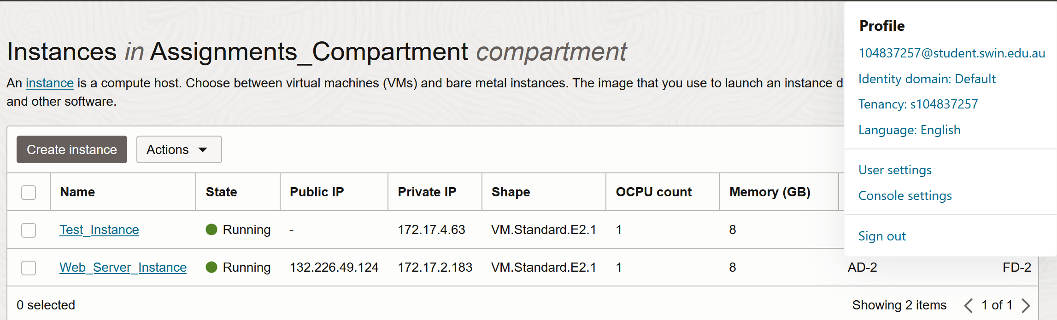

*Figure 12: Web_Server_Instance and Test_Instance*

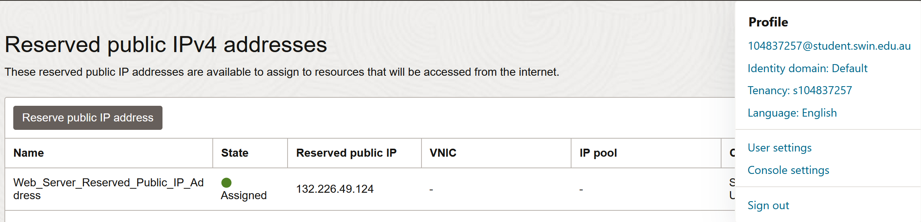

*Figure 13: Reserved Public IP Setup for Web Server*

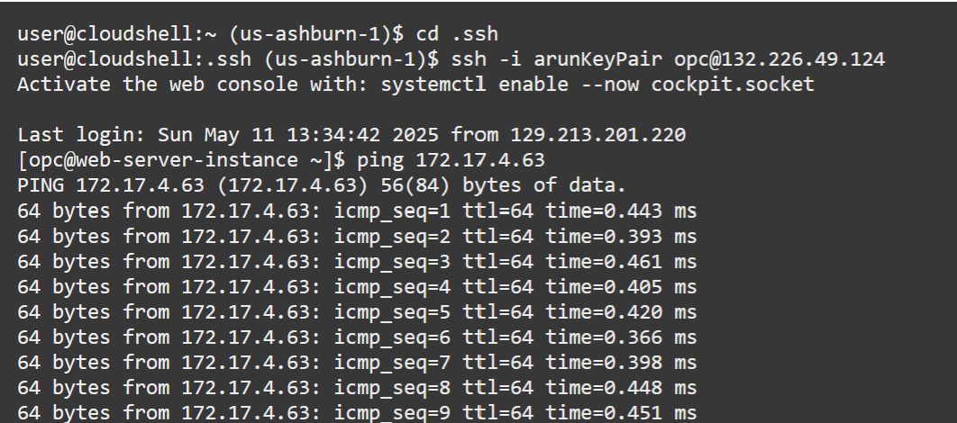

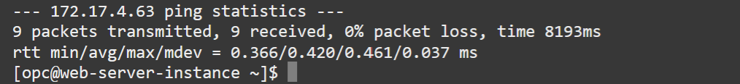  
*Figure 14: Successful Ping from Web_Server_Instance to Test_Instance*

**D. MySQL Database Setup**

A MySQL Database version 8.0.41 was launched using the MySQL2 shape with 50GB storage. Public access was disabled. phpMyAdmin was used to connect and manage the database [2]. A new database *photoalbum* was created with a table called *photosDB,* withthe below columns.

* photo_title (VARCHAR)
* description (VARCHAR)
* creation_date (DATE)
* keywords (VARCHAR)
* object_reference (VARCHAR)

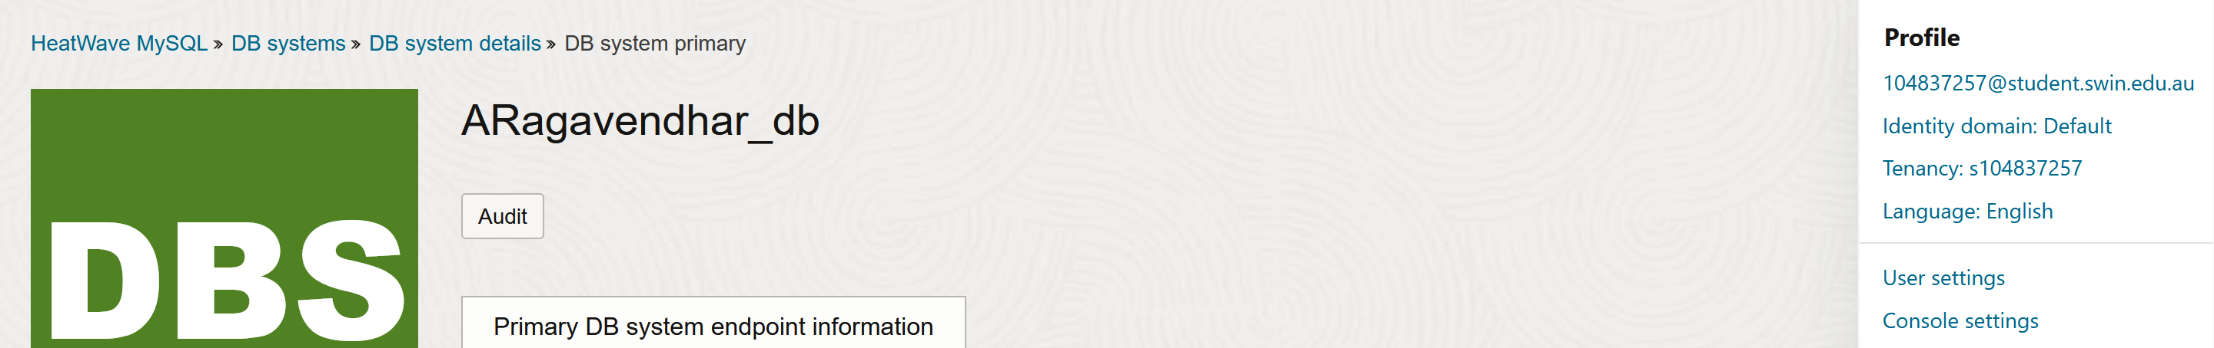

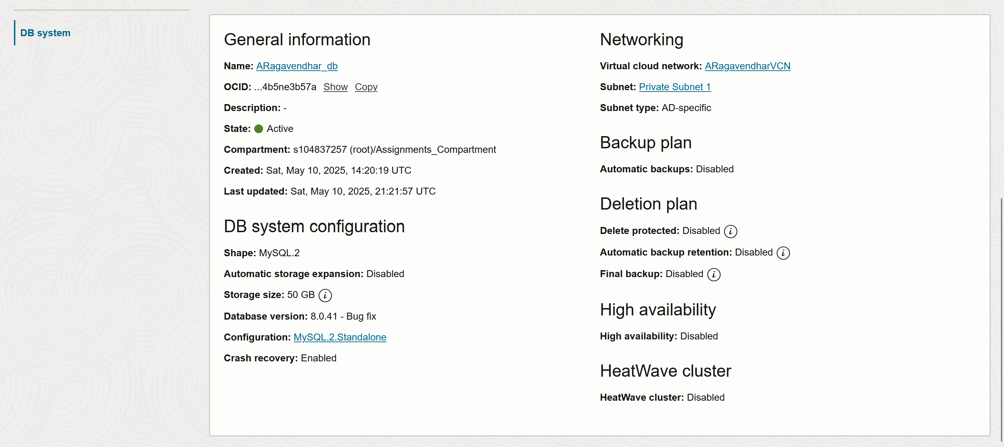

*Figure 15: OCI MySQL Database Instance Configuration Settings*

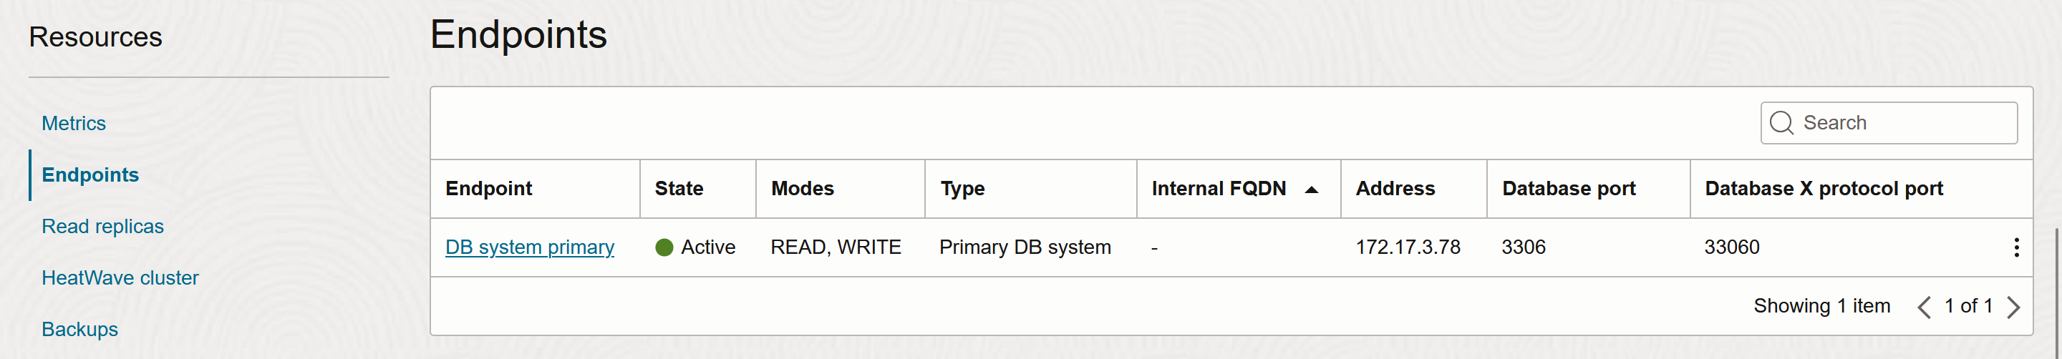

*Figure 16: OCI MySQL Database Endpoints*

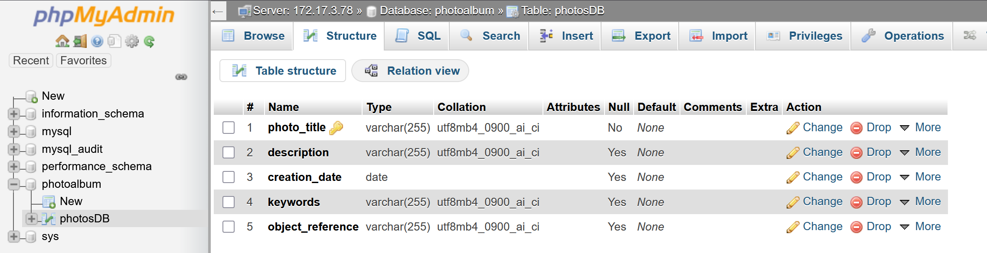

*Figure 17: phpMyAdmin Showing Table Schema*

**E. Security Lists**

Custom security lists were applied to each subnet, following the least privilege principle. PublicSubnet2SL allowed SSH and HTTP access from any source, enabled ICMP traffic to the test instance subnet, and accepted traffic from the MySQL database subnet. Meanwhile, PrivateSubnet1SL was restricted to allow traffic only from the web server in Public Subnet 2 to the MySQL server, ensuring communication was limited to what was strictly necessary [1,2].

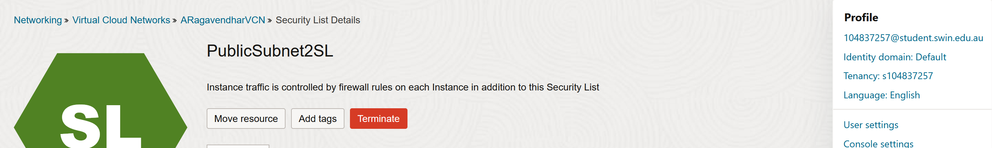

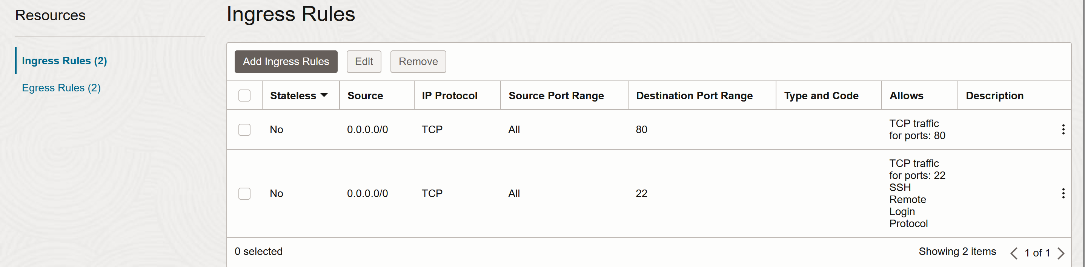

*Figure 18: Ingress Rules for PublicSubnet2SL*

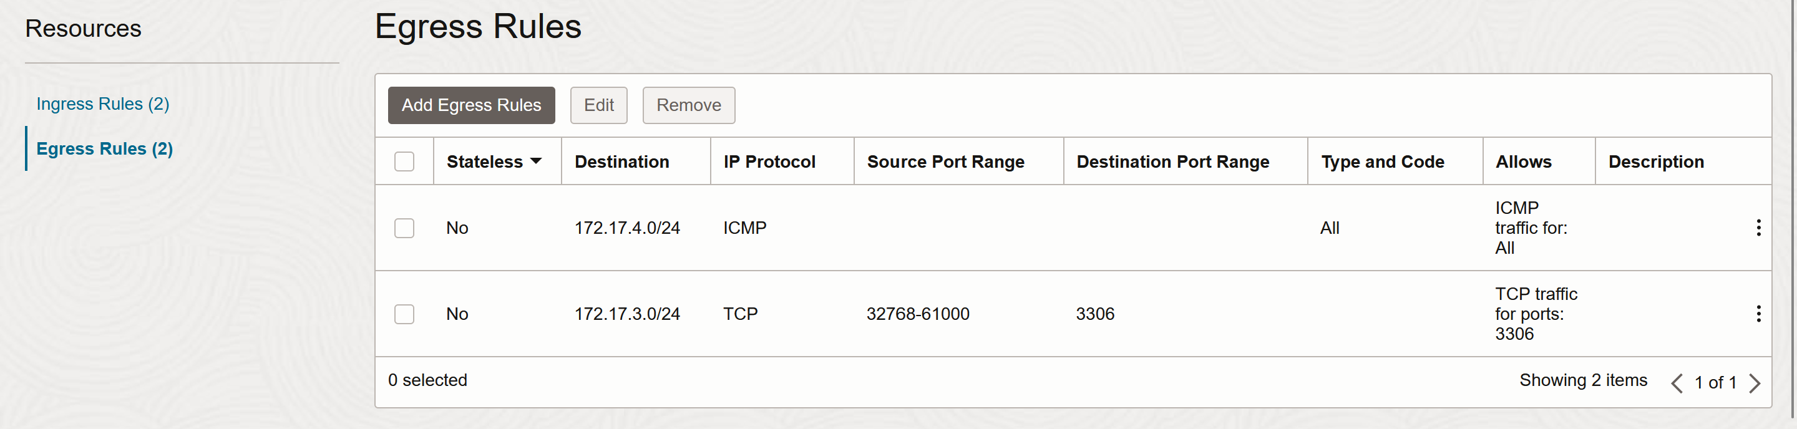

*Figure 19: Egress Rules for PublicSubnet2SL*

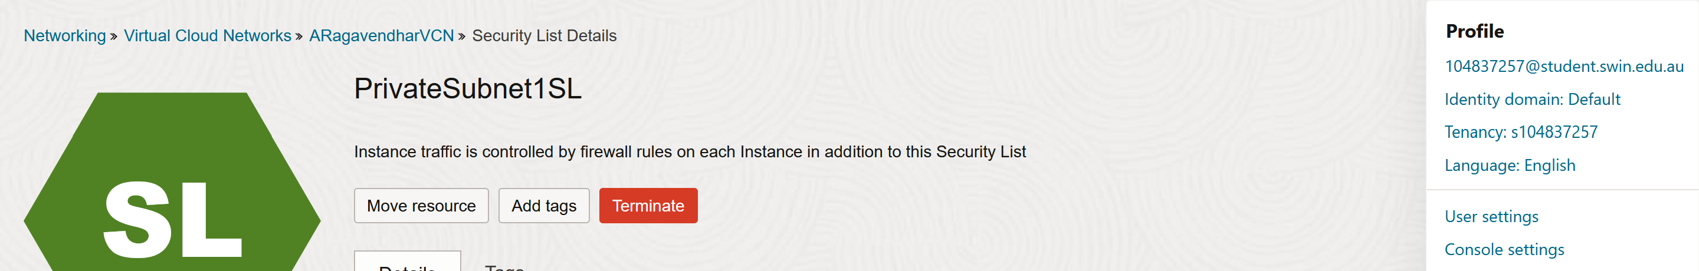  
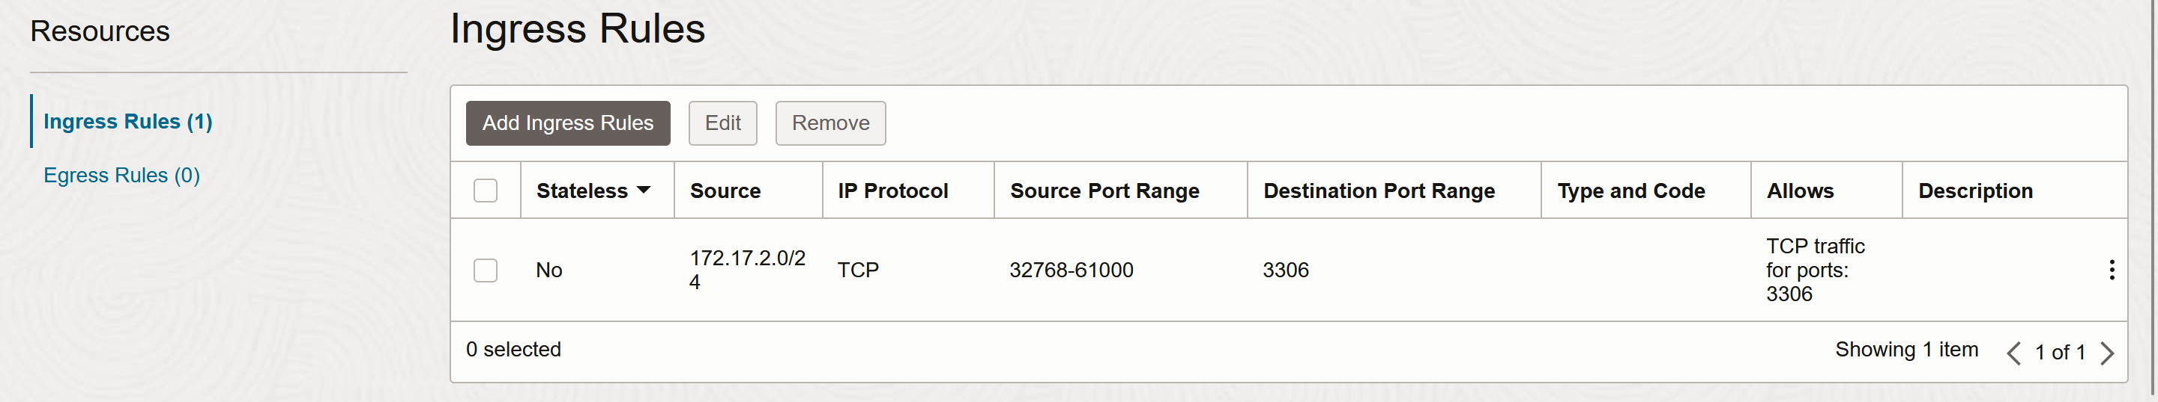

*Figure 20: Ingress Rules for PrivateSubnet1SL*

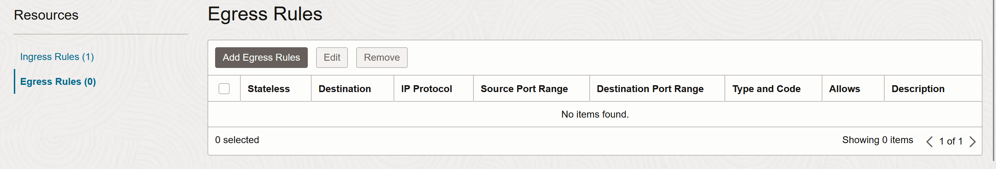

*Figure 21: Egress Rules for PrivateSubnet1SL*

# **III. PHOTO ALBUM APPLICATION DEPLOYMENT**

**A. OCI Object Storage Bucket**

A bucket called *ARagavendhar_bucket* was created. Public access was enabled at the bucket level, not on individual objects. This was done by setting bucket visibility to public access from the management console. Photos were uploaded using the console and the default URL links were opened and checked to verify objects creation [3].

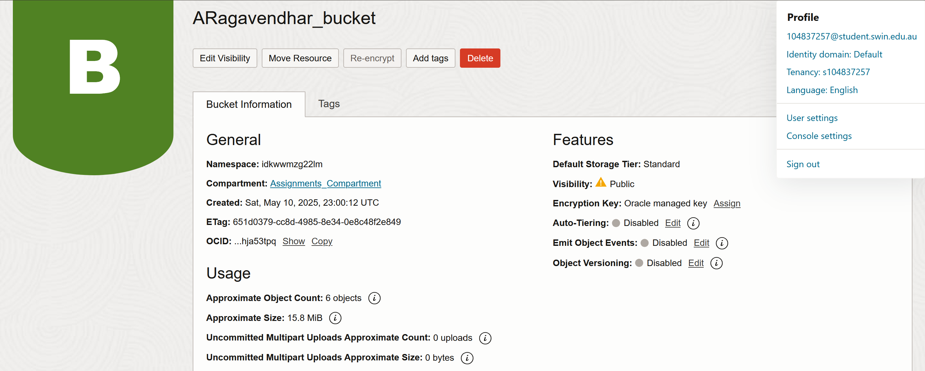

*Figure 22: OCI Object Storage Bucket Settings – Public Visibility selected from console*

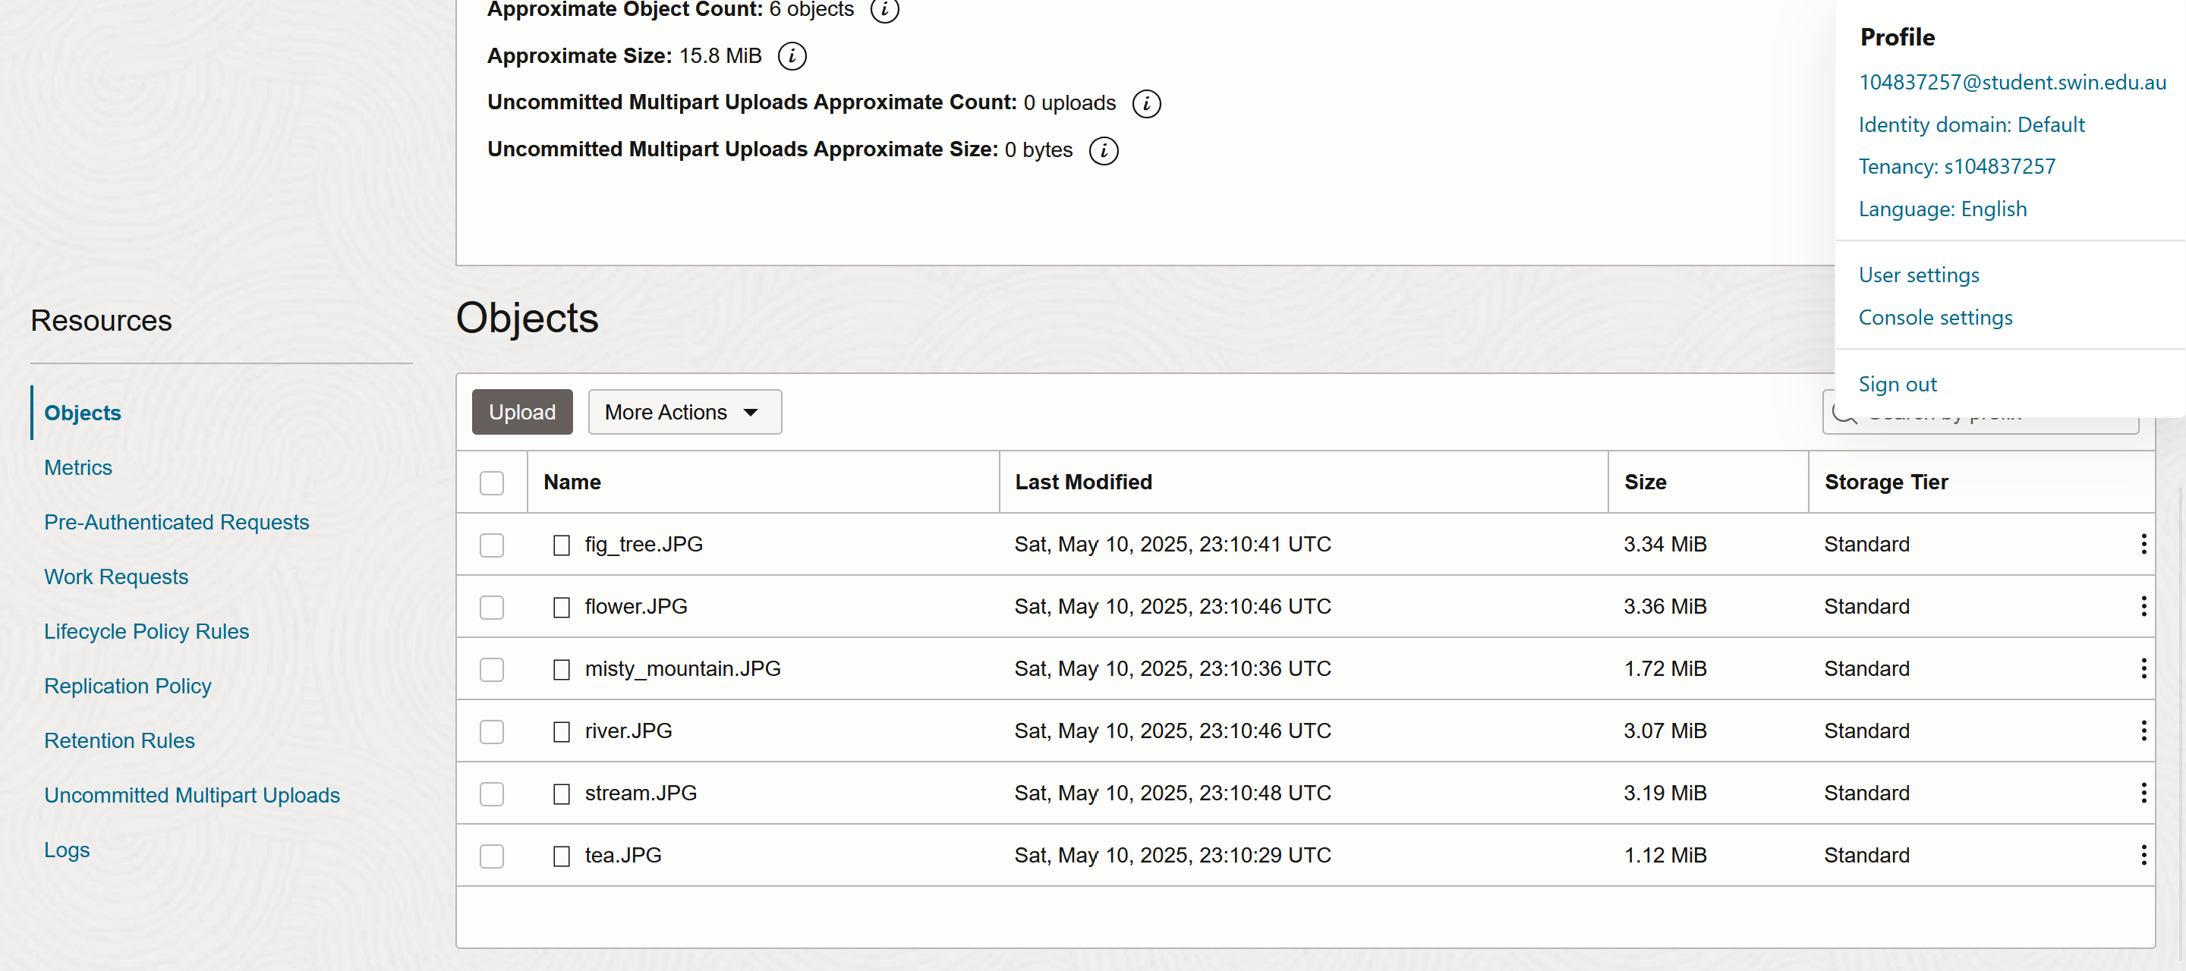  
*Figure 23: Uploaded Photo Objects in the Bucket*

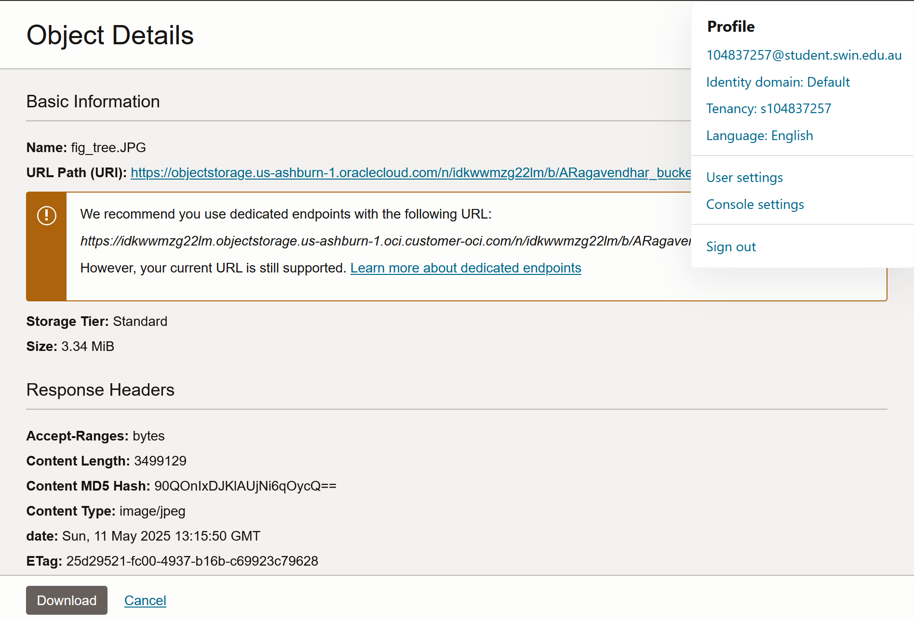

*Figure 24: public access URL of fig_tree object from the bucket*

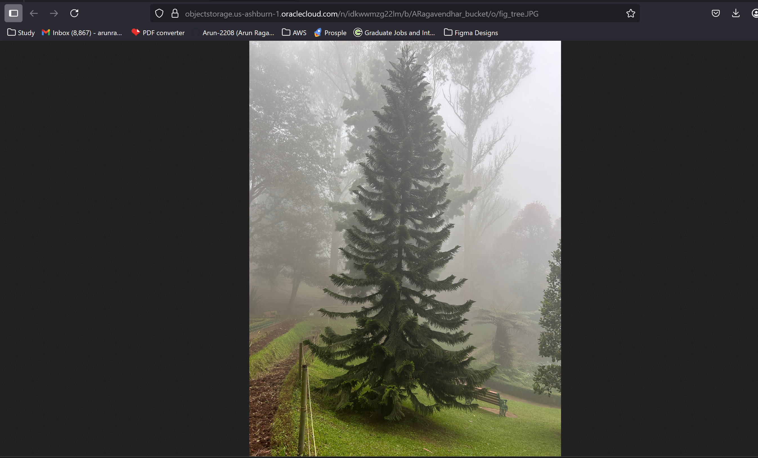

*Figure 25: Public Access Confirmation via Object URL*

**B. Metadata Entry and Storage in MySQL DB**

The metadata for each image was entered into the photosDB table in the database using phpMyAdmin. Each record included the object’s individual default URL in the object_reference column.

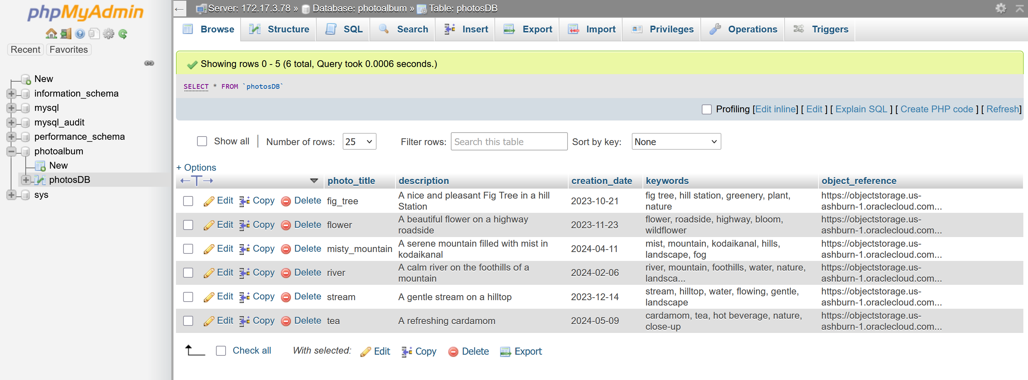

*Figure 26: phpMyAdmin Showing Metadata Records in photosDB table*

**C. Web Application Setup**

The provided photo album code was deployed in /var/www/html/cos80001/photoalbum/. The constants.php file was updated to reflect OCI database settings and column names. The application became accessible. Upon testing, the webpage successfully rendered uploaded images alongside metadata in a tabular form.

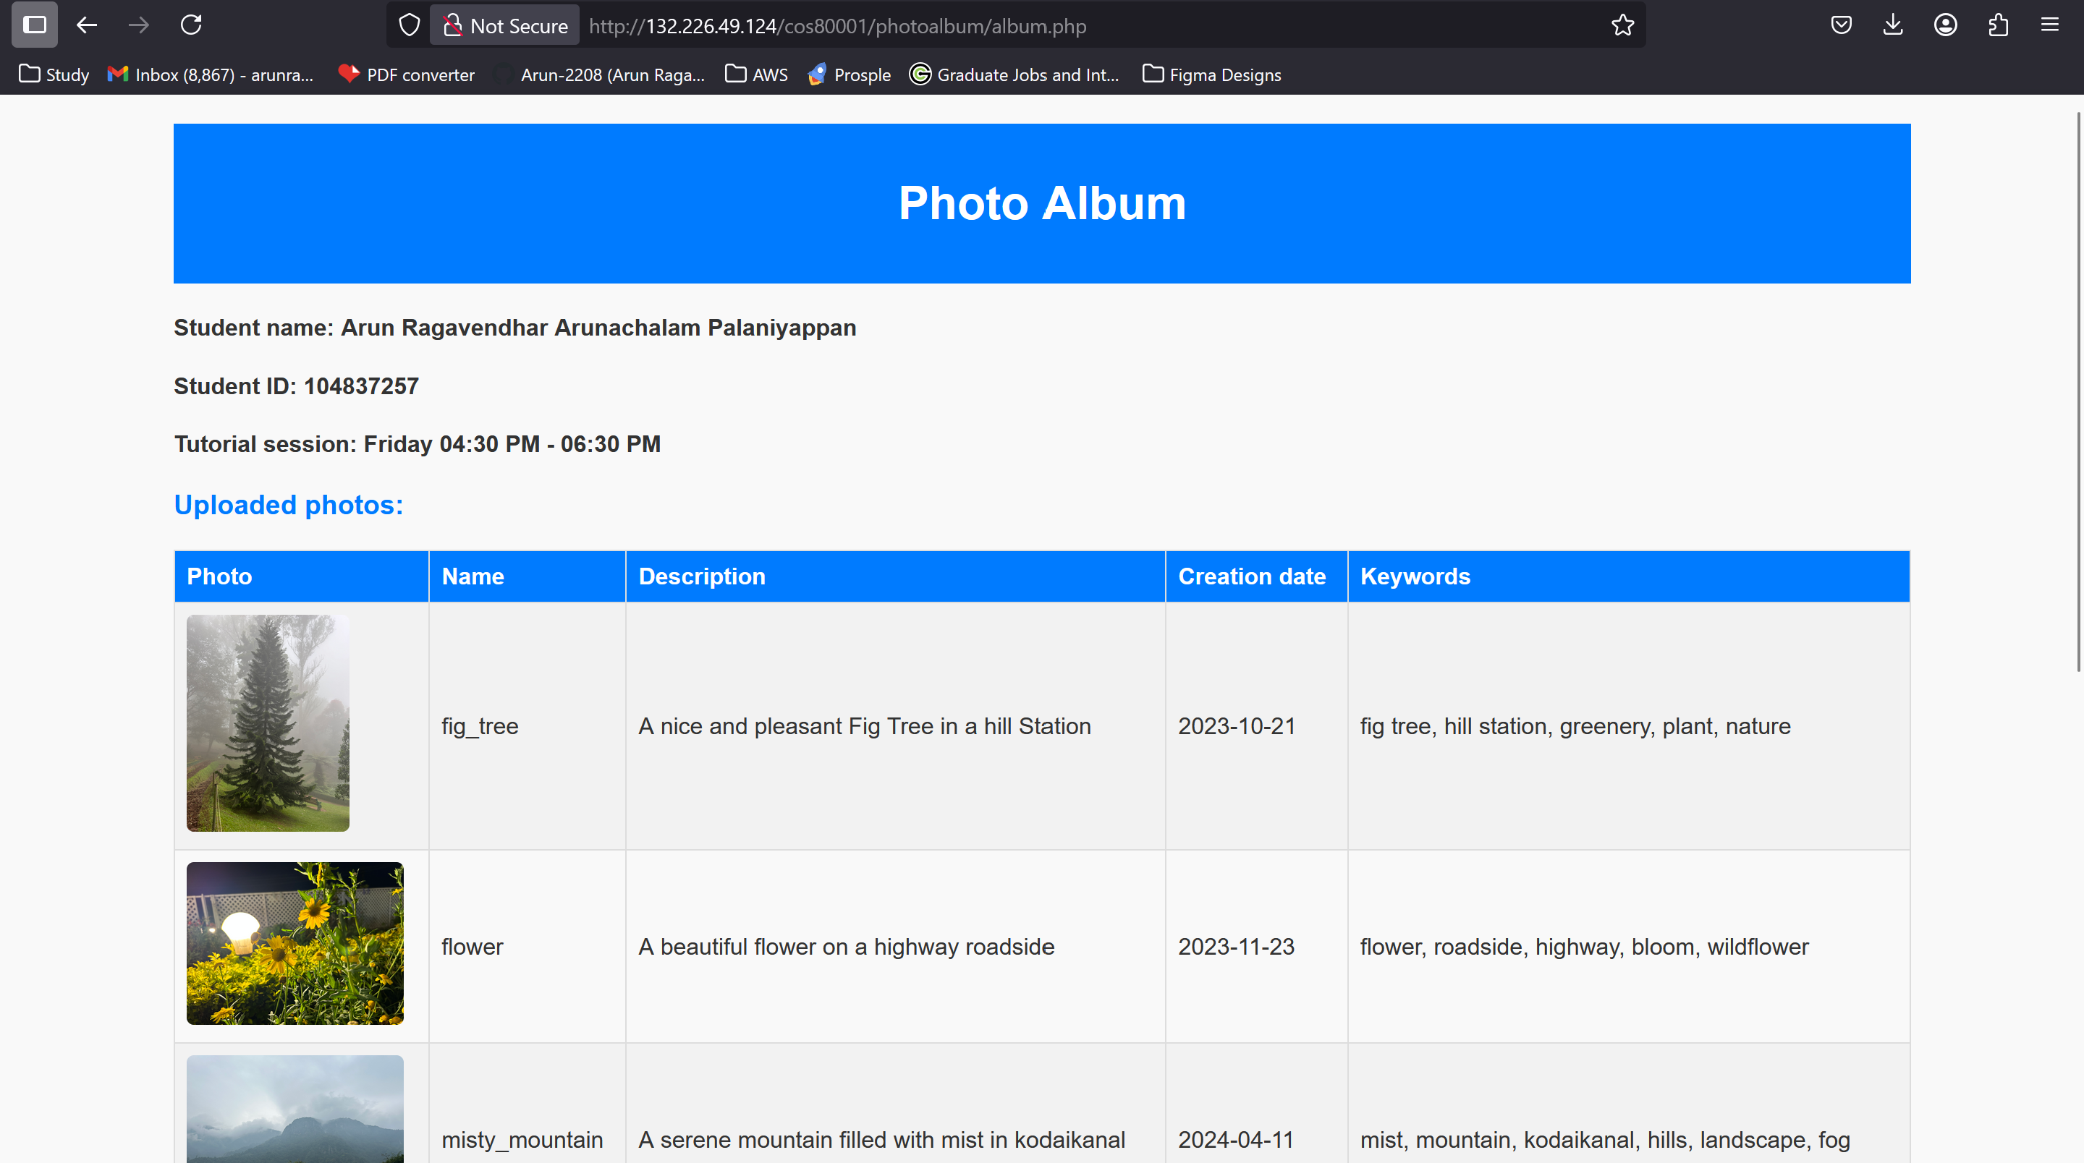

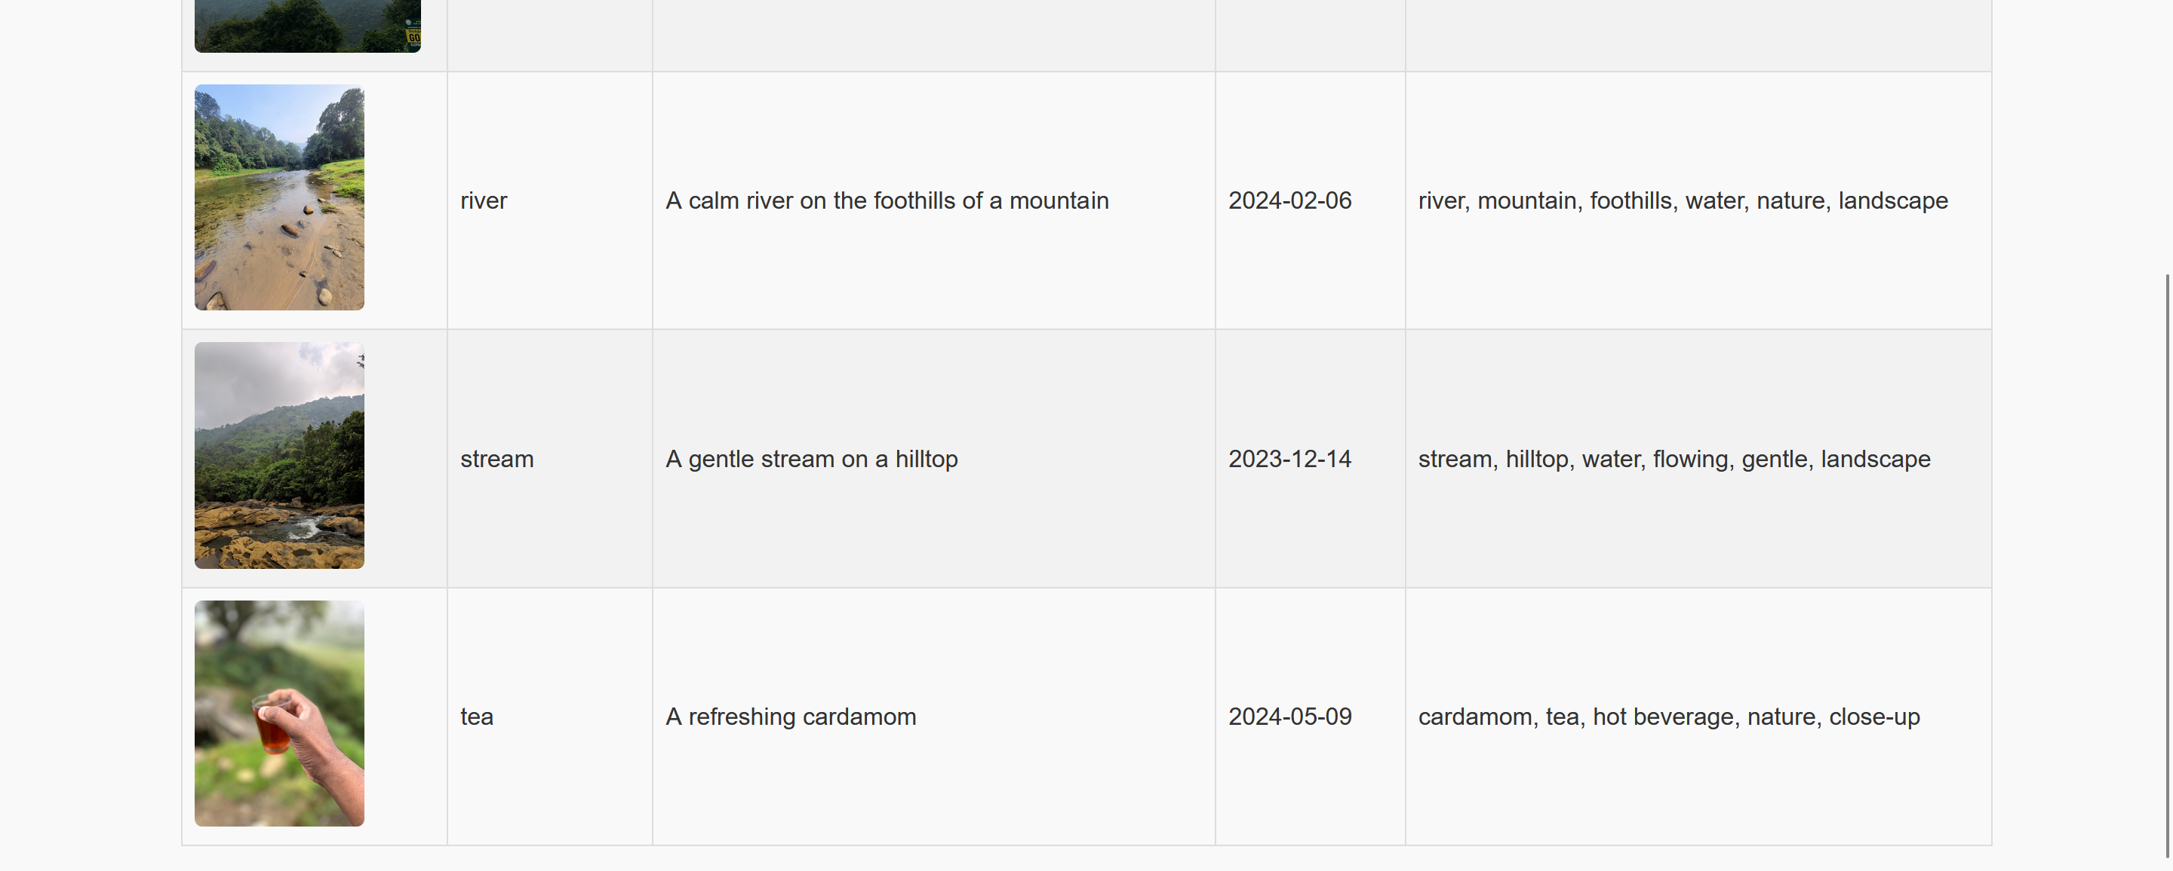

*Figure 27: album.php Showing Photoalbum Gallery with Metadata*

# **IV. TESTING AND VALIDATION**

To verify that the deployed infrastructure and application met all functional and security requirements, a series of tests were conducted. The main objectives of validation were to ensure correct connectivity across subnets, proper public access to the website and object storage, and full application functionality.

**A. Ping Connectivity Between Web Server and Test Instance**

The web server (bastion host) in Public Subnet 2 was used to SSH into and run a successful ping command to the test instance located in Private Subnet 2. This confirmed internal connectivity between subnets and validated both the Network Security Group (NSG) and Security List (SL) configurations.

**B. Photo Album Website Access Test**

Multiple test images stored in the OCI Object Storage bucket were correctly displayed, with associated metadata loaded from the MySQL database. This confirmed the correct setup of the PHP application, successful database connection, and proper configuration of public bucket visibility.

URL: ***http://132.226.49.124/cos80001/photoalbum/album.php***

**C. phpMyAdmin Database Test**

phpMyAdmin was used to view and manage the photosDB table. Manual insertions and updates were successful. Metadata was verified against live records shown on the album webpage, confirming database integrity and accessibility via the PHP backend.

**D. Object Storage Access Test**

All uploaded images were accessible through their public URLs directly from the Object Storage bucket, confirming the correct public visibility configuration at the bucket level and adherence to assignment guidelines.

**E. Website Restart and Reserved IP Persistence**

The web server was stopped and restarted multiple times to verify that the Reserved Public IP remained attached. The URL remained unchanged, confirming a persistent and stable endpoint as required.

# **V. CHALLENGES AND LEARNINGS**

One of the main issues during deployment involved a conflict between Network Security Groups (NSGs) and the default Security Lists. The default lists were still active and overrode the NSG settings, preventing the intended rules from taking effect. This was resolved by clearing all rules from the default lists, which then allowed the NSGs to function properly. Another challenge was with the Reserved Public IP setup. Initially, the web server was assigned a temporary public IP that changed after every reboot. To fix this, the default IP was removed, and a Reserved Public IP was manually created and attached to the instance, providing a fixed and reliable external address.

There were also difficulties accessing phpMyAdmin. Even though Apache and PHP were installed correctly, the php-mysql module was missing, causing the phpMyAdmin interface to fail. This was fixed by running `sudo dnf install php-mysqlnd` and restarting the Apache server with `sudo systemctl restart httpd`.Lastly, for Object Storage access, rather than applying permissions to each image or generating Pre-Authenticated Requests (PARs), the bucket's visibility was configured at the bucket level to allow public access. This enabled all uploaded photos to be accessed directly via their default public URLs, fulfilling the assignment’s access requirements without additional configuration.

# **VI. CONCLUSION**

The photo album website was successfully deployed on Oracle Cloud Infrastructure (OCI), meeting all the assignment requirements. A secure Virtual Cloud Network (VCN) was set up with clearly defined public and private subnets, and internet access was controlled through an Internet Gateway. The given PHP application was customised to store photo metadata in a MySQL database and display images from an Object Storage bucket. It was hosted on a virtual machine running Apache, with security further enhanced using a Network Security Group. Each component was configured using OCI best practices, and the system worked reliably, demonstrating solid understanding of cloud-based deployment.

# **VII. REFERENCES**

[1] Oracle Cloud Infrastructure Documentation. (2024). Virtual Cloud Network (VCN). <https://docs.oracle.com/en-us/iaas/Content/Network/Tasks/managingVCNs.htm>  
[2] Oracle Cloud Infrastructure. (2024). Managing MySQL Databases on OCI. <https://docs.oracle.com/en-us/iaas/mysql-database/doc/index.html>  
[3] Oracle Cloud Infrastructure. (2024). Object Storage Overview. <https://docs.oracle.com/en-us/iaas/Content/Object/Concepts/objectstorageoverview.htm>  
[4] Oracle Cloud Infrastructure. (2024). Reserved Public IP Addresses.

# **VIII. APPENDIX**

## **A. Abbreviations**

OCI: Oracle Cloud Infrastructure

VCN: Virtual Cloud Network

CIDR: Classless Inter-Domain Routing

NSG: Network Security Group

SL: Security List

VM: Virtual Machine

PHP: Hypertext Preprocessor

DB: Database

URL: Uniform Resource Locator

ICMP: Internet Control Message Protocol

HTTP: HyperText Transfer Protocol

SSH: Secure Shell

PAR: Pre-Authenticated Request

## **B. List of Figures**

Figure 1: IAM user created for Tutor

Figure 2: VCN Created in OCI Using CIDR Block 172.17.0.0/16

Figure 3: The 4 subnets and their CIDRs and Availability Domains

Figure 4: Public Subnet 1 configurations – associated route table and security list

Figure 5: Public Subnet 2 configurations – associated route table and security list

Figure 6: Private Subnet 1 configurations – associated route table and security list

Figure 7: Private Subnet 2 configurations – associated route table and security list

Figure 8: The public route table attached to the internet gateway

Figure 9: The private route table with no internet access

Figure 10: Web-tierNSG with Ingress (4 rules) and Egress (1 rule) Settings

Figure 11: Test-InstanceNSG with Ingress (1 rule) and Egress (1 rule) Settings

Figure 12: Web_Server_Instance and Test_Instance

Figure 13: Reserved Public IP Setup for Web Server

Figure 14: Successful Ping from Web_Server_Instance to Test_Instance

Figure 15: OCI MySQL Database Instance Configuration Settings

Figure 16: OCI MySQL Database Endpoints

Figure 17: phpMyAdmin Showing Table Schema

Figure 18: Ingress Rules for PublicSubnet2SL

Figure 19: Egress Rules for PublicSubnet2SL

Figure 20: Ingress Rules for PrivateSubnet1SL

Figure 21: Egress Rules for PrivateSubnet1SL

Figure 22: OCI Object Storage Bucket Settings – Public Visibility selected from console

Figure 23: Uploaded Photo Objects in the Bucket

Figure 24: Public access URL of fig_tree object from the bucket

Figure 25: Public Access Confirmation via Object URL

Figure 26: phpMyAdmin Showing Metadata Records in photosDB table

Figure 27: album.php Showing Photoalbum Gallery with Metadata